TRYHACKME LAB REPORT

Nmap Live Host Discovery
Internship: DG Interns HUB — Week 2
Domain: Cybersecurity — Network Reconnaissance
Platform: TryHackMe
Room Name: Nmap Live Host Discovery

1. Aim
To understand how Nmap discovers active hosts on a network and learn how different discovery probes help identify reachable devices.

2. Objectives
- Understand live host discovery.
- Learn common Nmap discovery options.
- Understand ICMP, TCP and ARP discovery probes.
- Interpret host discovery results.
- Understand why firewalls may affect host discovery.
- Practise network discovery in an authorized lab.

3. Introduction
Live host discovery is the process of identifying which devices are reachable on a network.
Before scanning ports, a security analyst may discover active hosts to understand which systems are available for further investigation.
Nmap supports several discovery methods, including ICMP echo requests, TCP probes and ARP requests on local Ethernet networks.
A host that does not respond to discovery probes is not necessarily offline. A firewall may block the probes or the device may be configured not to respond.

4. Theory

4.1 ICMP Discovery
ICMP is a network-layer protocol used for diagnostics and error reporting.
Nmap can use ICMP Echo Requests to discover responsive hosts.
Example:
nmap -PE -sn TARGET_IP
- -PE requests ICMP Echo-based discovery.
- -sn disables the port scan and performs host discovery only.

4.2 TCP SYN Discovery
TCP SYN discovery sends TCP SYN probes to specified ports to determine whether a host responds.
Example:
nmap -PS22,80,443 -sn TARGET_IP
A response may indicate that the target is reachable, even if the port does not complete a normal connection.

4.3 TCP ACK Discovery
TCP ACK discovery sends TCP packets with the ACK flag set.
Example:
nmap -PA80,443 -sn TARGET_IP
A response may indicate that a host is reachable. Firewalls can influence the result.

4.4 ARP Discovery
ARP maps an IPv4 address to a MAC address on a local network.
When scanning a directly connected Ethernet network, Nmap commonly uses ARP requests for host discovery.
Example:
sudo nmap -sn 192.168.56.0/24
Replace the example subnet with your authorized lab network.

4.5 Disabling Host Discovery
The -Pn option tells Nmap to skip normal host discovery and treat the specified targets as online for scanning purposes.
Example:
nmap -Pn -p 80 TARGET_IP
This does not prove that the host is online; it simply skips the usual discovery stage.

5. Important Nmap Options
Option | Purpose
-sn | Host discovery without port scanning
-PE | ICMP Echo discovery probe
-PP | ICMP Timestamp discovery probe
-PM | ICMP Address Mask discovery probe
-PS | TCP SYN discovery probe
-PA | TCP ACK discovery probe
-PU | UDP discovery probe
-PR | ARP discovery on a local Ethernet network
-Pn | Skip host discovery
-n | Disable DNS resolution
The effectiveness of these options depends on the target network, privileges and filtering rules.

6. Practical Methodology

Step 1: Open the Room
- Sign in to TryHackMe.
- Open the Nmap Live Host Discovery room.
- Read the instructions for each task.
- Start the required lab machine, if applicable.

Step 2: Identify the Target
Record the target IP address or subnet provided by the room.
Only scan targets that are part of the authorized exercise.

Step 3: Perform Host Discovery
Follow the room instructions and use the appropriate discovery options.
For each task, record the command used, the output returned and what the result indicates.

Step 4: Interpret the Results
Check:
- Whether Nmap reports the host as up.
- Which discovery method was used.
- Whether any responses were received.
- Whether filtering could explain a lack of response.
- Whether the result agrees with the lab's expected behaviour.

Step 5: Save Evidence
Take screenshots of the relevant commands, output and completed task answers. Store the evidence in your Week 2 Findings folder.

7. Results and Findings
Complete the following table using your actual results.
Item | Actual Result
Target IP or subnet | [Enter lab target]
Discovery method | [Enter method used]
Hosts discovered | [Enter observed number]
Responsive host addresses | [Enter observed addresses]
Important response | [Describe the result]
Possible filtering observed | [Enter observation or N/A]
Do not enter estimated host counts or invented IP addresses.

8. Security Relevance
Host discovery is useful during authorized network assessments because it helps identify reachable devices before deeper investigation.
SOC analysts may also investigate unusual discovery traffic, including:
- ICMP probes sent to multiple hosts.
- TCP SYN or ACK probes across a network.
- ARP requests for many local addresses.
- Repeated discovery activity from an unexpected device.
These behaviours can be legitimate administration or security testing. Analysts should check the source, timing, authorization and surrounding network traffic before determining whether the activity is suspicious.

9. Challenges and Limitations
- Firewalls can block discovery probes.
- Some hosts may not respond to ICMP.
- ARP discovery is mainly useful on the local Ethernet network.
- A missing response does not prove that a host is offline.
- Network configuration and scan privileges affect the results.

10. Learning Outcomes
After completing this lab, the intended learning outcomes are:
- Understand live host discovery.
- Recognize common Nmap discovery probes.
- Understand the role of ICMP, TCP and ARP.
- Interpret basic host discovery output.
- Explain how firewalls can influence scan results.
- Document network reconnaissance findings.

11. Evidence Checklist
- Screenshot of the TryHackMe room.
- Screenshots of important task results.
- Actual discovery commands and output recorded.
- Answers to the room questions saved.
- Evidence stored in the Week 2 Findings folder.

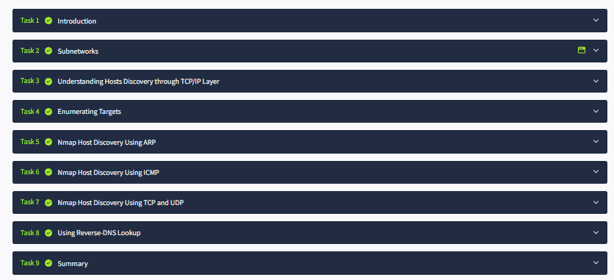

12. Conclusion
The Nmap Live Host Discovery lab introduces methods for identifying reachable devices on a network. It demonstrates how ICMP, TCP and ARP probes can help discover hosts and how filtering can affect the results.
These skills are useful for authorized network assessment, troubleshooting and recognizing reconnaissance activity during security monitoring.

